**Q1. Write the JavaScript code to change the content and color of the HTML element below when we click button?**

**<h1 id="demo">May the code be with you.</h1> 4**

**Q2. Write a JavaScript program to calculate multiplication and division of two numbers (input from the user).**

**Sample form :  
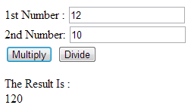 4**

**Q3. Write a Java Script Program to create 8-character random password generator. 6**

**Q4. Write a JavaScript conditional statement to find the sign of product of three numbers. Display an alert box with the specified sign. 6**

**Q5. Write a JavaScript function to check whether a string is blank or not. 4**

**Q6. Write a java script program to find area of rectangle when width and height are given. 4**

**Q7. Write a JavaScript function to capitalize the first letter of a string. 6**

**Sample Input: cybrom technology bhopal**

**Ans : Cybrom Technology Bhopal.**

**Q8 WAP to change the background color of body with click on buttons {3 buttons green,black,orange} 6**